Unit 5: Structured Query Language (SQL)
Structured Query Language (SQL) is the standard language used to interact with relational databases.
- It allows users to store, retrieve, update and manage data efficiently through simple commands.
- It is known for its user-friendly syntax and powerful capabilities; SQL is widely used across industries.
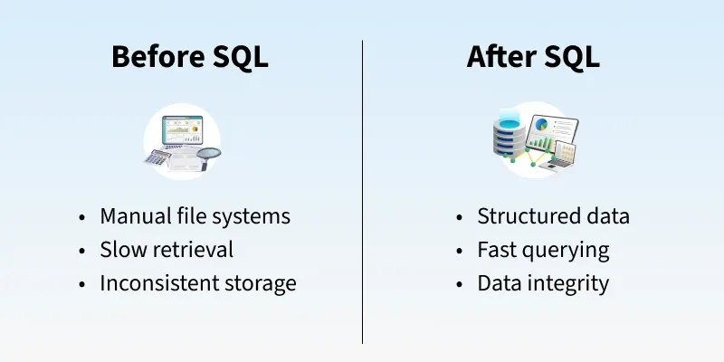
SQL Working
We interact with databases using SQL queries. DBMS tools like MySQL and SQL Server have their own SQL engine and an interface where users can write and execute SQL queries.
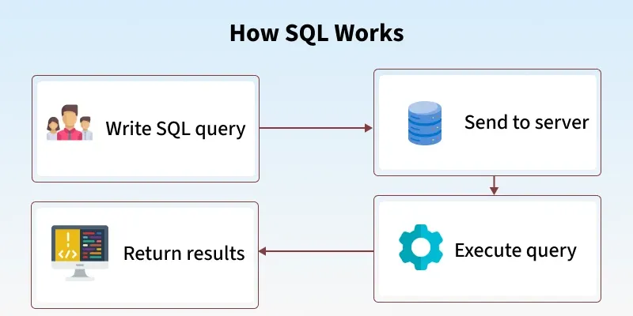
Below are the detailed steps involved in the SQL query execution.
- Input – The user sends a SQL query (like SELECT or INSERT).
- Parsing – The system checks if the query is written correctly.
- Optimization – It chooses the fastest way to run the query.
- Execution – The database runs the query.
- Output – The result or confirmation is sent back to the user.
Components of a SQL System
- Database: A structured collection of data stored in tables with rows and columns.
- Tables: Store data and apply rules to keep it accurate and consistent.
- Indexes: Help the database find data faster without scanning the whole table.
- Views: Virtual tables created from SELECT queries for easy access to data.
- Stored Procedures: Pre-saved SQL code that runs tasks and improves performance and security.
- Transactions: Group of SQL actions that either all succeed or all fail to keep data safe.
- Security & Permissions: Control who can view, change, or manage database data.
- Joins: Combine data from different tables based on relationships.
Rules for Writing SQL Queries
There are certain rules for SQL which would ensure consistency and functionality across databases. By following these rules, queries will be well formed and well executed in any database.
- Semicolon (;): Ends an SQL statement.
- Case-Insensitive: SQL keywords like SELECT and INSERT are not case-sensitive.
- Whitespace: Spaces and new lines are allowed for better readability.
- Reserved Words: Do not use SQL keywords as names, or write them in quotes/backticks.
Comments
- Single-line: -- comment
- Multi-line: /* comment */
Data Constraints: Use NOT NULL, UNIQUE, PRIMARY KEY, etc., to ensure data accuracy.
String Values: Enclose strings in single quotes ('text').
Naming Rules:
- We Start with a letter
- We can only use Max 30 characters
- We only use letters, numbers and underscores (_)
Different SQL Commands or Queries
Structured Query Language (SQL) commands are standardized instructions used by developers to interact with data stored in relational databases. These commands allow for the creation, manipulation, retrieval and control of data, as well as database structures. SQL commands are categorized based on their specific functionalities:
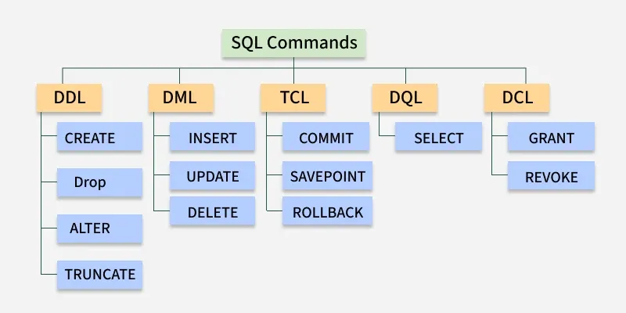Different SQL Commands or Queries
1. Data Definition Language
DDL (Data Definition Language) commands are used to create, change, and delete database objects.Database engineers use commands like CREATE to make tables, views, and indexes, and ALTER or DROP to modify or remove them.
Command | Description
CREATE | Creates a new table, a view on a table, or some other object in the database.
ALTER | Modifies an existing database object, such as a table
DROP | Deletes an entire table, a view of a table, or other objects in the database
TRUNCATE | Removes all records from a table but keeps the table structure intact.
RENAME | It is used to change the name of an existing database object, such as a table.
2. Data Manipulation Language
A relational database can be updated with new data using data manipulation language (DML) statements. The INSERT command, for instance, is used by an application to add a new record to the database.
Command | Description
INSERT | Creates a record.
UPDATE | Modifies records.
DELETE | Deletes records.
3. Data Query Language
Data retrieval instructions are written in the data query language (DQL), which is used to access relational databases. The SELECT command is used by software programs to filter and return particular results from a SQL table.
4. Data Control language
DCL commands manage user access to the database by granting or revoking permissions. Database administrators use DCL to enforce security and control access to database objects.
Command | Description
GRANT | Gives a privilege to the user.
REVOKE | Takes back privileges granted by the user.
5. Transaction Control Language
TCL commands manage transactions in relational databases, ensuring data integrity and consistency. These commands are used to commit changes or roll back operations in case of errors.
Command | Description
COMMIT | Saves all changes made during the current transaction on a permanent basis. Some databases provide an auto-commit feature, which can be configured using settings.
ROLLBACK | Reverts changes made during the current transaction, ensuring no unwanted changes are saved.
SAVEPOINT | Sets a point within a transaction to which changes can be rolled back, allowing partial rollbacks
Benefits of SQL
- Efficient: Works fast even with large and complex data.
- Standard: Works on most database systems.
- Scalable: Can handle small to very large databases.
- Flexible: Supports advanced logic using extensions like PL/SQL or T-SQL.
Limitations of SQL
- Complex: Advanced tuning and optimization can be difficult.
- Scalability Issues: Not ideal for huge or unstructured data.
- Different Versions: Some SQL features vary by database.
- Not Real-Time: Traditional SQL is not built for real-time analytics.
Real-World Applications of SQL
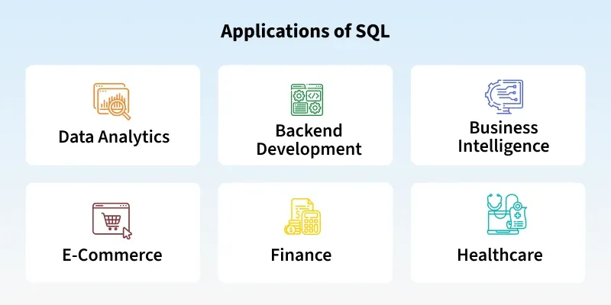
- E-Commerce: Manage customer orders, product catalogs and inventory.
- Healthcare: Maintain patient records and appointment schedules.
- Banking: Analyze transaction histories and generate financial reports.
- Web Development: Power dynamic websites with user-specific content.
- Machine Learning and Data Science: Combine SQL databases with tools like Python, R and TensorFlow to streamline machine learning workflows.

Overview of SQL –
- SQL stands for Structured Query Language. It is used for storing and managing data in relational database management system (RDMS).

- It is a standard language for Relational Database System. It enables a user to create, read, update and delete relational databases and tables.

- All the RDBMS like MySQL, Informix, Oracle, MS Access and SQL Server use SQL as their standard database language.

- SQL allows users to query the database in a number of ways, using English-like statements.

How SQL Works?
When you are executing an SQL command for any RDBMS, the system determines the best way to carry out your request and SQL engine figures out how to interpret the task.
There are various components included in this process. These components are −
- Query Dispatcher
- Optimization Engines
- Classic Query Engine
- SQL Query Engine, etc.
A classic query engine handles all the non-SQL queries, but a SQL query engine won't handle logical files. Following is a simple diagram showing the SQL Architecture −
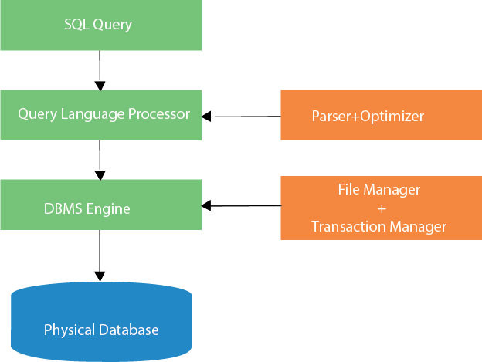

SQL Data Definition -
SQL commands are like instructions to a table.
It is used to interact with the database with some operations. It is also used to perform specific tasks, functions, and queries of data.
These SQL commands are mainly categorized into five categories:
- DDL – Data Definition Language
- DQL – Data Query Language
- DML – Data Manipulation Language
- DCL – Data Control Language
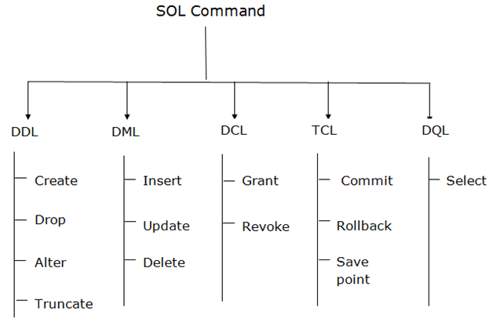
- TCL – Transaction Control Language

1. Data Definition Language (DDL)
- DL changes the structure of the table like creating a table, deleting a table, altering a table, etc.
- All the command of DDL are auto-committed that means it permanently save all the changes in the database.
Here are some commands that come under DDL:

- CREATE
- ALTER
- DROP
- TRUNCATE

a. CREATE It is used to create a new table in the database.
Syntax: CREATE TABLE TABLE_NAME (COLUMN_NAME DATATYPES[,....]);
Example: CREATE TABLE EMPLOYEE(Name VARCHAR(20), Email VARCHAR(100), DOB DATE);
b. DROP: It is used to delete both the structure and record stored in the table.
Syntax DROP TABLE table_name;
Example DROP TABLE EMPLOYEE;
c. ALTER: It is used to alter the structure of the database. This change could be either to modify the characteristics of an existing attribute or probably to add a new attribute.
Syntax: To add a new column in the table
ALTER TABLE table_name ADD column_name COLUMN-definition;
To modify existing column in the table:
ALTER TABLE table_name MODIFY(column_definitions....);
EXAMPLE
- ALTER TABLE STU_DETAILS ADD(ADDRESS VARCHAR(20));
- ALTER TABLE STU_DETAILS MODIFY (NAME VARCHAR(30));
d. TRUNCATE: It is used to delete all the rows from the table and free the space containing the table.
Syntax: TRUNCATE TABLE table_name;
Example: TRUNCATE TABLE EMPLOYEE;
================================================================

2. Data Manipulation Language
- DML commands are used to modify the database. It is responsible for all form of changes in the database.
- The command of DML is not auto-committed that means it can't permanently save all the changes in the database. They can be rollback.

Here are some commands that come under DML:
- INSERT
- UPDATE
- DELETE
a. INSERT: The INSERT statement is a SQL query. It is used to insert data into the row of a table.
Syntax:
INSERT INTO TABLE_NAME (col1, col2, col3,..col N) VALUES (value1, value2,..valueN);
Or
INSERT INTO TABLE_NAME VALUES (value1, value2, value3, .... valueN);
For example: INSERT INTO javatpoint (Author, Subject) VALUES ("Sonu", "DBMS");
b. UPDATE: This command is used to update or modify the value of a column in the table.
Syntax:UPDATE table_name SET [column_name1= value1,...column_nameN = valueN.] [WHERE CONDITION]
For example: UPDATE students SET User_Name = 'Sonu' WHERE Student_Id = 3;
c. DELETE: It is used to remove one or more row from a table.
Syntax: DELETE FROM table_name [WHERE condition];
For example: DELETE FROM javatpoint WHERE Author="Sonu";
======================================================

3. Data Control Language
DCL commands are used to grant and take back authority from any database user.
Here are some commands that come under DCL:
- Grant
- Revoke

a. Grant: It is used to give user access privileges to a database.
Example GRANT SELECT, UPDATE ON MY_TABLE TO SOME_USER, ANOTHER_USER;
b. Revoke: It is used to take back permissions from the user.
Example REVOKE SELECT, UPDATE ON MY_TABLE FROM USER1, USER2;
======================================================

4. Transaction Control Language
TCL commands can only use with DML comm ands like INSERT, DELETE and UPDATE only.
These operations are automatically committed in the database that's why they cannot be used while creating tables or dropping them.
Here are some commands that come under TCL:
- COMMIT
- ROLLBACK
- SAVEPOINT
a. Commit: Commit command is used to save all the transactions to the database.
Syntax COMMIT;
Example DELETE FROM CUSTOMERS WHERE AGE = 25; COMMIT;
b. Rollback: Rollback command is used to undo transactions that have not already been saved to the database.
Syntax: ROLLBACK;
Example: DELETE FROM CUSTOMERS WHERE AGE = 25; ROLLBACK;
c. SAVEPOINT: It is used to roll the transaction back to a certain point without rolling back the entire transaction.
Syntax: SAVEPOINT SAVEPOINT_NAME;
======================================================

5. Data Query Language
DQL is used to fetch the data from the database. It uses only one command:
- SELECT
a. SELECT: This is the same as the projection operation of relational algebra. It is used to select the attribute based on the condition described by WHERE clause.
Syntax SELECT expressions FROM TABLES WHERE conditions;
Example: SELECT emp_name FROM employee WHERE age > 20;
======================================================

SQL Constraints
SQL constraints are used to specify rules for data in a table.
Constraints can be specified when the table is created with the CREATE TABLE statement, or after the table is created with the ALTER TABLE statement.

Syntax
CREATE TABLE table_name (
column1 datatype constraint,
column2 datatype constraint,
column3 datatype constraint,
....
);
SQL constraints are used to specify rules for the data in a table.
Constraints are used to limit the type of data that can go into a table. This ensures the accuracy and reliability of the data in the table. If there is any violation between the constraint and the data action, the action is aborted.
Constraints can be column level or table level. Column level constraints apply to a column, and table level constraints apply to the whole table.
The following constraints are commonly used in SQL:
- NOT NULL - Ensures that a column cannot have a NULL value
- UNIQUE - Ensures that all values in a column are different
- PRIMARY KEY - A combination of a NOT NULL and UNIQUE. Uniquely identifies each row in a table
- FOREIGN KEY - Prevents actions that would destroy links between tables
- CHECK - Ensures that the values in a column satisfies a specific condition
- DEFAULT - Sets a default value for a column if no value is specified
- CREATE INDEX - Used to create and retrieve data from the database very quickly

SQL - NULL Values –
- The term NULL in SQL is used to specify that a data value does not exist in the database.
- It is not the same as an empty string or a value of zero, and it signifies the absence of a value or the unknown value of a data field.

- Some common reasons why a value may be NULL −
- The value may not be provided during the data entry.
- The value is not yet known.

- It is important to understand that you cannot use comparison operators such as “=”, “<”, or “>” with NULL values.
- This is because the NULL values are unknown and could represent any value.
- Instead, you must use “IS NULL” or “IS NOT NULL” operators to check if a value is NULL.

Syntax: The basic syntax of NULL while creating a table.
SQL> CREATE TABLE CUSTOMERS (
ID INT NOT NULL,
NAME VARCHAR (20) NOT NULL,
AGE INT NOT NULL,
ADDRESS CHAR (25),
SALARY DECIMAL (18, 2),
PRIMARY KEY (ID)
);

Here, NOT NULL signifies that column should always accept an explicit value of the given data type.

There are two columns where we did not use NOT NULL, which means these columns could be NULL.

A field with a NULL value is the one that has been left blank during the record creation.

Example: Let us insert some values into the above created table using the following query.

INSERT INTO CUSTOMERS (ID, NAME, AGE, ADDRESS, SALARY) VALUES (1, 'Ramesh', '32', 'Ahmedabad', 2000);
INSERT INTO CUSTOMERS (ID, NAME, AGE, ADDRESS, SALARY) VALUES (2, 'Khilan', '25', 'Delhi', 1500);
INSERT INTO CUSTOMERS (ID, NAME, AGE, ADDRESS, SALARY) VALUES (3, 'Kaushik', '23', 'Kota', 2000);
INSERT INTO CUSTOMERS (ID, NAME, AGE, ADDRESS, SALARY) VALUES (4, 'Chaitali', '25', 'Mumbai', 6500);
INSERT INTO CUSTOMERS (ID, NAME, AGE, ADDRESS, SALARY) VALUES (5, 'Hardik','27', 'Bhopal', 8500);
INSERT INTO CUSTOMERS (ID, NAME, AGE, ADDRESS, SALARY) VALUES (6, 'Komal', '22', 'MP', NULL);
INSERT INTO CUSTOMERS (ID, NAME, AGE, ADDRESS, SALARY) VALUES (7, 'Muffy', '24', 'Indore', NULL);

To verify whether the table CUSTOMERS is created or not, use the following query
SELECT * FROM CUSTOMERS;

The table is successfully created in the database.
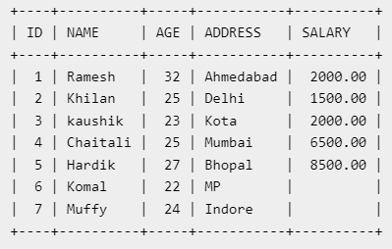

IS NOT NULL Query -
Now, let us try to retrieve the records present in the table that are not null using the IS NOT NULL operator −
SELECT ID, NAME, AGE, ADDRESS, SALARY
FROM CUSTOMERS
WHERE SALARY IS NOT NULL;

Output: The above query would produce the following result –

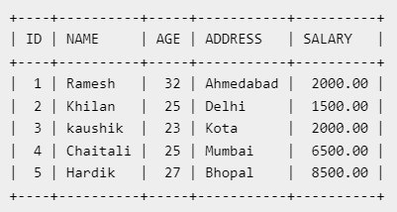

===================================================================

IS NULL Query
Let us try to retrieve the records present in the table that are null using the IS NULL operator -
SELECT ID, NAME, AGE, ADDRESS, SALARY
FROM CUSTOMERS
WHERE SALARY IS NULL;

Output: The above query would produce the following result –
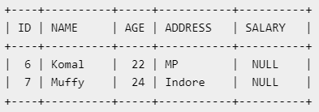

Updating NULL values in a table-
You can update the NULL values present in a table using the UPDATE statement in SQL. To do so, you can use the IS NULL operator in your WHERE clause to select the rows with NULL values and then set the new value using the SET keyword.
use the following query
SQL> UPDATE CUSTOMERS SET SALARY = 9000 WHERE SALARY IS NULL;

Output: Let us try to verify whether the specified record(s) in the table is updated or not using the following query − SELECT * FROM CUSTOMERS;

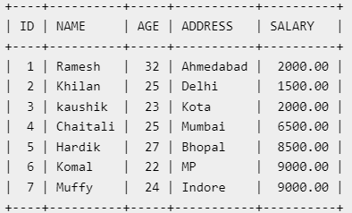

=================================================================

SQL UNIQUE Constraint
The UNIQUE constraint ensures that all values in a column are different.
Both the UNIQUE and PRIMARY KEY constraints provide a guarantee for uniqueness for a column or set of columns.
A PRIMARY KEY constraint automatically has a UNIQUE constraint.
However, you can have many UNIQUE constraints per table, but only one PRIMARY KEY constraint per table.
SQL UNIQUE Constraint on CREATE TABLE
The following SQL creates a UNIQUE constraint on the "ID" column when the "Persons" table is created:
CREATE TABLE Persons (
ID int NOT NULL UNIQUE,
LastName varchar(255) NOT NULL,
FirstName varchar(255),
Age int
); OR
CREATE TABLE Persons (
ID int NOT NULL,
LastName varchar(255) NOT NULL,
FirstName varchar(255),
Age int,
UNIQUE (ID)
);

SQL UNIQUE Constraint on ALTER TABLE
To create a UNIQUE constraint on the "ID" column when the table is already created, use the following SQL:
ALTER TABLE Persons
ADD UNIQUE (ID);

SQL PRIMARY KEY Constraint
The PRIMARY KEY constraint is used to uniquely identify each record in a table.
Primary keys must contain unique values, and cannot contain NULL values.
Each table can have only ONE primary key.
The primary key can be a single column or a combination of columns.

SQL PRIMARY KEY on CREATE TABLE
The following SQL creates a PRIMARY KEY on the "ID" column when the "Persons" table is created:
CREATE TABLE Persons (
ID int NOT NULL,
LastName varchar(255) NOT NULL,
FirstName varchar(255),
Age int,
PRIMARY KEY (ID)
);
OR
CREATE TABLE Persons (
ID int PRIMARY KEY,
LastName varchar(255) NOT NULL,
FirstName varchar(255),
Age int
);

SQL PRIMARY KEY on ALTER TABLE
To create a PRIMARY KEY constraint on the "ID" column when the table is already created, use the following SQL:
ALTER TABLE Persons
ADD PRIMARY KEY (ID);

SQL CHECK Constraint
The CHECK constraint is used to limit the value range that can be placed in a column.
If you define a CHECK constraint on a column it will allow only certain values for this column.
If you define a CHECK constraint on a table it can limit the values in certain columns based on values in other columns in the row.

SQL CHECK on CREATE TABLE
The following SQL creates a CHECK constraint on the "Age" column when the "Persons" table is created. The CHECK constraint ensures that the age of a person must be 18, or older:
CREATE TABLE Persons (
ID int NOT NULL,
LastName varchar(255) NOT NULL,
FirstName varchar(255),
Age int CHECK (Age>=18)
);

SQL CHECK on ALTER TABLE
To create a CHECK constraint on the "Age" column when the table is already created, use the following SQL:
ALTER TABLE Persons
ADD CHECK (Age>=18);

SQL DEFAULT Constraint
The DEFAULT constraint is used to set a default value for a column.
The default value will be added to all new records, if no other value is specified.

SQL DEFAULT on CREATE TABLE
The following SQL sets a DEFAULT value for the "City" column when the "Persons" table is created:
CREATE TABLE Persons (
ID int NOT NULL,
LastName varchar(255) NOT NULL,
FirstName varchar(255),
Age int,
City varchar(255) DEFAULT 'Pune'
);
The DEFAULT constraint can also be used to insert system values, by using functions like GETDATE():
CREATE TABLE Orders (
ID int NOT NULL,
OrderNumber int NOT NULL,
OrderDate date DEFAULT GETDATE()
);

SQL DEFAULT on ALTER TABLE
To create a DEFAULT constraint on the "City" column when the table is already created, use the following SQL:
ALTER TABLE Persons
ALTER City SET DEFAULT 'Pune';

EXAMPLE:
🔹 STEP 1: Create Database and Use It
CREATE DATABASE CollegeDB;
USE CollegeDB;

🔹 STEP 2: Create Table with SQL Constraints
Table: Student
Constraints covered:
- PRIMARY KEY
- NOT NULL
- UNIQUE
- CHECK
- DEFAULT
CREATE TABLE Student (
Student_ID INT PRIMARY KEY,
Student_Name VARCHAR(50) NOT NULL,
Email VARCHAR(50) UNIQUE,
Gender CHAR(1) CHECK (Gender IN ('M','F')),
Marks INT CHECK (Marks >= 0 AND Marks <= 100),
Department VARCHAR(30) DEFAULT 'CS'
);
👉 constraints are rules applied on columns to ensure valid data.

🔹 STEP 3: Insert Valid Records (Successful Execution)
INSERT INTO Student VALUES
(1, 'Amit', 'amit@gmail.com', 'M', 85, 'IT');

INSERT INTO Student VALUES
(2, 'Sneha', 'sneha@gmail.com', 'F', 90, 'HR');

🔹 STEP 4: Display Data
SELECT * FROM Student;

🔹 STEP 5: Demonstrate Constraint Violations
❌ PRIMARY KEY violation
INSERT INTO Student VALUES
(1, 'Rahul', 'rahul@gmail.com', 'M', 70, 'CS');
➡️ Error: Duplicate primary key

❌ NOT NULL violation
INSERT INTO Student VALUES
(3, NULL, 'test@gmail.com', 'M', 60, 'CS');
➡️ Error: Student_Name cannot be NULL

❌ UNIQUE constraint violation
INSERT INTO Student VALUES
(4, 'Neha', 'amit@gmail.com', 'F', 75, 'CS');
➡️ Error: Email must be unique

❌ CHECK constraint violation
INSERT INTO Student VALUES
(5, 'Kiran', 'kiran@gmail.com', 'X', 50, 'CS');
➡️ Error: Gender must be M or F
INSERT INTO Student VALUES
(6, 'Pooja', 'pooja@gmail.com', 'F', 150, 'CS');
➡️ Error: Marks out of range

🔹 STEP 6: DEFAULT Constraint Demo
INSERT INTO Student (Student_ID, Student_Name, Email, Gender, Marks)
VALUES (7, 'Ravi', 'ravi@gmail.com', 'M', 65);
SELECT * FROM Student;
➡️ Department will automatically be CS

🔹 STEP 7: FOREIGN KEY Constraint Demo
A FOREIGN KEY is a field (or collection of fields) in one table, that refers to the PRIMARY KEY in another table.
The table with the foreign key is called the child table, and the table with the primary key is called the referenced or parent table.
A FOREIGN KEY constraint is a concept in SQL that enforces a valid relationship between two tables by ensuring that the values stored in the child table correspond to existing values in the parent table. This constraint protects the database from inconsistent or invalid relational data.
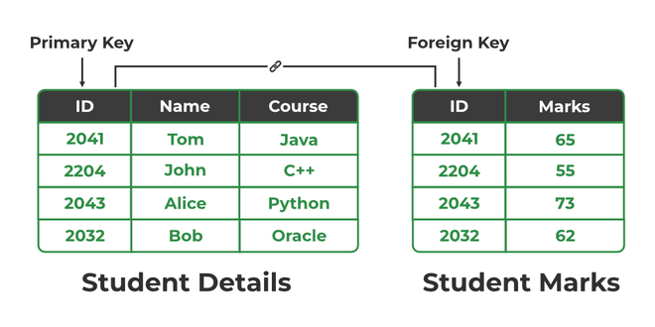
- Ensures child table values match valid primary keys in parent table.
- Blocks actions that create broken or unmatched table references.
🔹 Step 1: Create Parent Table
CREATE TABLE Department (
dept_id INT PRIMARY KEY,
dept_name VARCHAR(50) NOT NULL
);

🔹 Step 2: Create Child Table (With Foreign Key)
CREATE TABLE Employee (
emp_id INT PRIMARY KEY,
emp_name VARCHAR(50) NOT NULL,
salary INT CHECK (salary > 0),
dept_id INT,
FOREIGN KEY (dept_id) REFERENCES Department(dept_id)
);
NOTE: dept_id in Employee must match dept_id in Department.

🔹 Step 3: Insert Data in Parent Table
INSERT INTO Department VALUES (1, 'HR');
INSERT INTO Department VALUES (2, 'IT');
INSERT INTO Department VALUES (3, 'Finance');

🔹 Step 4: Valid Insert in Child Table
INSERT INTO Employee VALUES (101, 'Amit', 30000, 1);
INSERT INTO Employee VALUES (102, 'Neha', 40000, 2);
✔ Works because dept_id exists.
Select * from Department;
Select * from Employee;

🔹 Step 5: Invalid Insert (Foreign Key Violation)
INSERT INTO Employee VALUES (103, 'Rahul', 35000, 5);
❌ Error:
Cannot add or update a child row: foreign key constraint fails.
Department 5 does not exist, so insertion fails.
🔹 Step 6: Try Deleting Parent Record
DELETE FROM Department WHERE dept_id = 1;
❌ Error because Employee is referencing it.
Parent cannot be deleted if child exists.

ON DELETE CASCADE Example
Drop tables first:
DROP TABLE Employee;
DROP TABLE Department;
Recreate with CASCADE:
CREATE TABLE Department (
dept_id INT PRIMARY KEY,
dept_name VARCHAR(50)
);
CREATE TABLE Employee (
emp_id INT PRIMARY KEY,
emp_name VARCHAR(50),
dept_id INT,
FOREIGN KEY (dept_id) REFERENCES Department(dept_id)
ON DELETE CASCADE
);
Insert again:
INSERT INTO Department VALUES (1, 'HR');
INSERT INTO Employee VALUES (101, 'Amit', 1);
Select * from Department;
Select * from Employee;
Now delete:
DELETE FROM Department WHERE dept_id = 1;
✔ Employee record also deleted automatically.

ON UPDATE CASCADE Example – Self study topic

SQL constraints help maintain data accuracy, consistency, and integrity in a database.

Structure of SQL Queries –
SQL Queries form the backbone of database interactions.
They allow users to extract specific information from databases, enabling them to make informed decisions based on the data at hand.
Whether you are working with financial records, user data, or inventory information, Queries empower you to retrieve the exact data you need efficiently.

Components of SQL Queries –
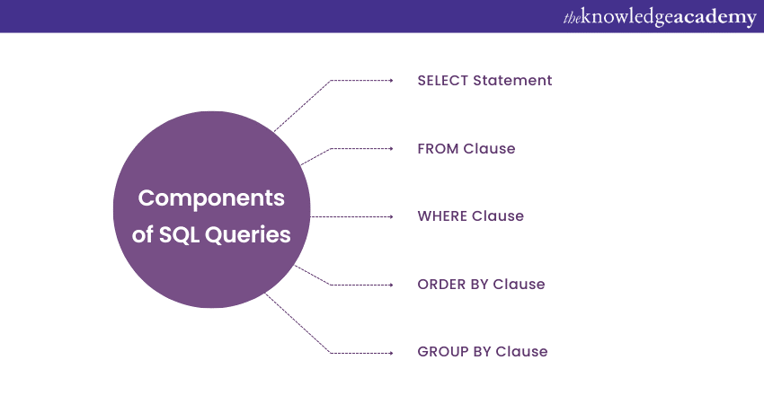
a) SELECT: "SELECT" is used to retrieve data from a database.
It allows you to specify which particular columns you want to fetch from a particular table.
b) FROM Clause: The FROM clause indicates the table from which you want to retrieve data. It identifies the source of data for your Query.
c) WHERE Clause: The WHERE clause is used to filter data based on specific conditions. It allows you to extract only the records that meet certain criteria.
d) ORDER BY Clause: The ORDER BY clause is used to sort the result set in either ascending or descending order based on one or multiple columns.
e) GROUP BY Clause: The GROUP BY clause is employed to group rows with identical values in one or multiple columns. It is often used along with aggregate functions.

Basic Operations –
The SQL reserved words and characters are called operators, which are used with a WHERE clause in a SQL query. In SQL, an operator can either be a unary or binary operator.
The unary operator uses only one operand for performing the unary operation, whereas the binary operator uses two operands for performing the binary operation.
SQL supports following types of operators:
- Arithmetic operators
- Comparison operators
- Logical operators
Click here for more details
practice by yourself.

SQL Operators: IN, NOT IN, BETWEEN, LIKE
These operators are used in the WHERE clause to filter records from a table.
They are called SQL Comparison Operators.
Syntax:
SELECT column_name
FROM table_name
WHERE condition;

1. IN Operator
Definition
The IN operator is used to check whether a value matches any value in a given list.
It is useful when we want to compare multiple values in one condition instead of writing multiple OR conditions.
Syntax
SELECT column_name
FROM table_name
WHERE column_name IN (value1, value2, value3);
Equivalent Condition
WHERE column = value1 OR column = value2 OR column = value3

Example Table
CREATE TABLE Student (
StudentID INT,
Name VARCHAR(20),
Department VARCHAR(20),
Marks INT
);

INSERT INTO Student VALUES
(101,'Amit','CS',75),
(102,'Neha','IT',82),
(103,'Rahul','CS',68),
(104,'Pooja','Electronics',90),
(105,'Karan','IT',72);

Student Table
StudentID | Name | Department | Marks
101 | Amit | CS | 75
102 | Neha | IT | 82
103 | Rahul | CS | 68
104 | Pooja | Electronics | 90
105 | Karan | IT | 72

SQL Demonstration
Example 1
Display students from CS and IT departments.
SELECT Name, Department
FROM Student
WHERE Department IN ('CS', 'IT');
Output
Name | Department
Amit | CS
Neha | IT
Rahul | CS
Karan | IT

2. NOT IN Operator
Definition
The NOT IN operator selects values that do NOT match the values in the given list.
Syntax
SELECT column_name
FROM table_name
WHERE column_name NOT IN (value1, value2);

SQL Demonstration
Example
Display students not from CS department.
SELECT Name, Department
FROM Student
WHERE Department NOT IN ('CS');
Output
Name | Department
Neha | IT
Pooja | Electronics
Karan | IT

3. BETWEEN Operator
Definition
The BETWEEN operator is used to select values within a specific range.
The range includes the starting and ending values.
Syntax
SELECT column_name
FROM table_name
WHERE column_name BETWEEN value1 AND value2;

SQL Demonstration
Example
Display students whose marks are between 70 and 85.
SELECT Name, Marks
FROM Student
WHERE Marks BETWEEN 70 AND 85;
Output
Name | Marks
Amit | 75
Neha | 82
Karan | 72

NOT BETWEEN
Used to select values outside a range.
Example
SELECT Name, Marks
FROM Student
WHERE Marks NOT BETWEEN 70 AND 85;

4. LIKE Operator
Definition
The LIKE operator is used to search for a pattern in text values.
It works with wildcards.

Wildcards Used in LIKE
Wildcard | Meaning
% | Represents any number of characters
_ | Represents a single character

LIKE Syntax
SELECT column_name
FROM table_name
WHERE column_name LIKE 'pattern';

SQL Demonstration
Example 1: Names starting with 'A'
SELECT Name
FROM Student
WHERE Name LIKE 'A%';
Result:
Amit

Example 2: Names ending with 'a'
SELECT Name
FROM Student
WHERE Name LIKE '%a';
Result:
Neha
Pooja

Example 3: Names containing 'oo'
SELECT Name
FROM Student
WHERE Name LIKE '%oo%';
Result:
Pooja

Example 4: Names with second letter 'a'
SELECT Name
FROM Student
WHERE Name LIKE '_a%';
Result:
Rahul
Karan

Quick Comparison
Operator | Purpose | Example
IN | Match values from a list | Department IN ('CS','IT')
NOT IN | Exclude values from a list | Department NOT IN ('CS')
BETWEEN | Select range of values | Marks BETWEEN 60 AND 80
LIKE | Pattern matching | Name LIKE 'A%'

Small Practice Questions:
- Display students whose department is CS or Electronics.
- Display students whose marks are between 70 and 90.
- Display students whose name starts with 'P'.
- Display students not from IT department.

Column-level vs Table-level Constraints (SQL)

Feature | Column-level constraint | Table-level constraint
Defined where? | Written with a column definition | Written after all columns
Applies to | Only one column | Can apply to one or multiple columns
Used for | Simple constraints | Complex/multi-column constraints
Common types | NOT NULL, UNIQUE, PRIMARY KEY (single column), CHECK, DEFAULT | PRIMARY KEY (composite), FOREIGN KEY, CHECK, UNIQUE

1️⃣ Column-level constraint
Defined immediately after the column.
Example:
CREATE TABLE Student (
id INT PRIMARY KEY,
name VARCHAR(50) NOT NULL,
age INT CHECK (age >= 18)
);
Here:
- PRIMARY KEY, NOT NULL, and CHECK are applied to individual columns

2️⃣ Table-level constraint
Defined after all columns.
Used when constraint involves multiple columns.
Example:
CREATE TABLE Enrollment (
student_id INT,
course_id INT,
PRIMARY KEY (student_id, course_id)
);
Here:
- Composite primary key uses two columns
- So, it must be table-level

- Column level: applied to one column
- Table level: applied to whole table or multiple columns

When to use
- Use column level → for single column rules
- Use table level → for composite primary key or foreign key

One-line exam answer
Column-level constraints are applied to a single column, whereas table-level constraints are defined separately and can apply to one or more columns in a table.

